DATA VISUALIZATION TECHNIQUES – FINAL SEMESTER PROJECT

PropertyPulse: Interactive Dubai Real Estate Intelligence System
Submitted by | Eman Malik  Ehtisham Younas  - Abdul Haseeb
Registration no | SP23-BDS-012  SP23-BDS-032  SP23-BDS-001
Section | BDS-7A
Date | 29TH May,2026
Submitted to | Ma’am Shahneela Naz

1. Dataset Overview

Dataset Description
The PropertyPulse system was developed using multiple Dubai real estate datasets containing information about:
- Property rental transactions
- Secondary market sales
- Off-plan property sales
- Area-wise property prices
- Dubai Metro station locations
The datasets were integrated to provide a comprehensive overview of Dubai’s real estate market and enable users to explore trends, pricing patterns, geographic distribution, and market activity.

Datasets Used
Dataset | Purpose
rentals.csv | Rental market analysis
secondary_sales.csv | Secondary property transactions
off_plan.csv | Off-plan property analysis
area_prices_monthly.csv | Area-wise price trends
metro_stations.csv | Geographic and location analysis

Dataset Characteristics
Attribute | Value
Total Datasets | 5
Data Type | Real Estate Transactions
Geographic Scope | Dubai, UAE
Data Format | CSV
Visualization Platform | D3.js Web Dashboard
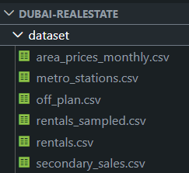

2. Data Preprocessing
Before visualization development, the datasets were cleaned and transformed to ensure consistency and accuracy.

Preprocessing Steps
- Removal of duplicate records.
- Handling missing values.
- Standardization of column names.
- Conversion of numerical fields into proper numeric formats.
- Date formatting and parsing.
- Filtering invalid transactions.
- Aggregation of data for visualization purposes.

Data Cleaning Process
The preprocessing phase improved data quality and ensured that visualizations accurately represented the underlying market trends.

3. Exploratory Data Analysis (EDA)
Exploratory Data Analysis was conducted to understand the structure of the data and identify patterns before designing the visualization system.

Dataset Summary
A preliminary analysis was performed to understand dataset size, attributes, and distributions.

Price Distribution Analysis
Property prices were analyzed to understand market distribution and identify high-value segments.

Area-wise Market Activity
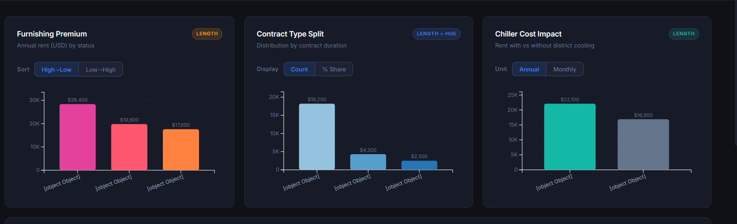Figure 6: Most active real estate locations.

Outlier Detection
A box plot analysis revealed the presence of several luxury properties with exceptionally high transaction values.

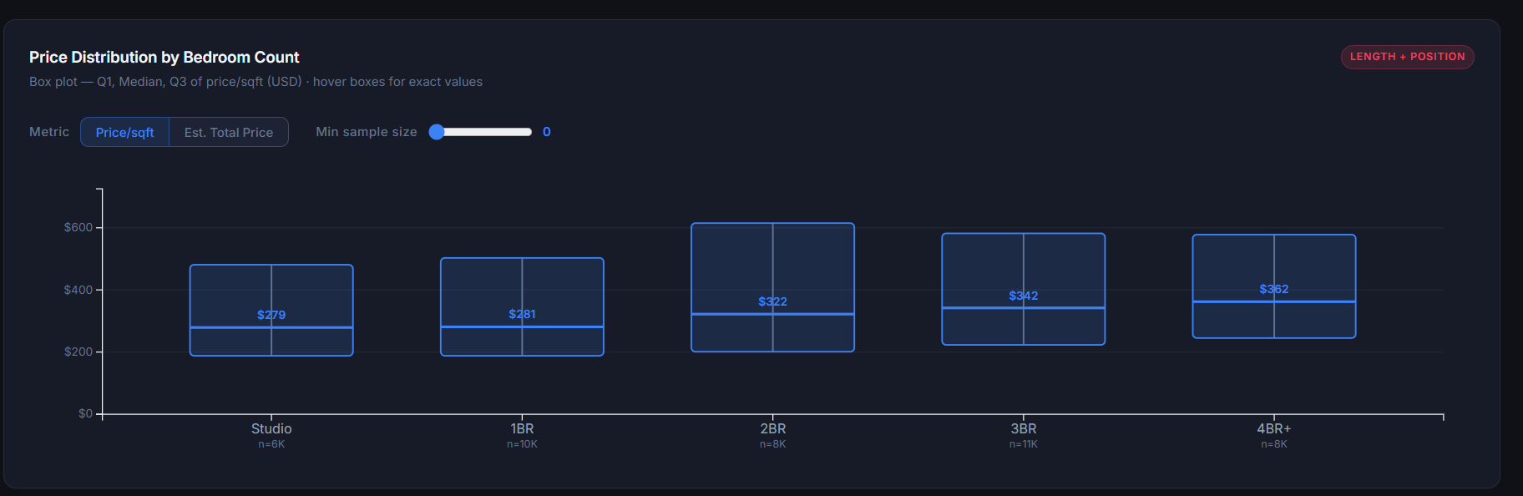Relationship Between Area and Price
Correlation analysis indicated a positive relationship between property area and market price.

Key Findings
- Property prices exhibit a right-skewed distribution.
- Certain Dubai locations dominate transaction volume.
- Larger properties generally command higher prices.
- Luxury properties form a distinct group of outliers.
- Market activity varies significantly across districts.

4. Choice of Visualizations and Justification
The dashboard was designed according to established visualization principles and D3.js best practices.

Line Chart
Purpose:
- Visualize market trends over time.
Justification: Line charts effectively communicate temporal patterns and changes in market activity.
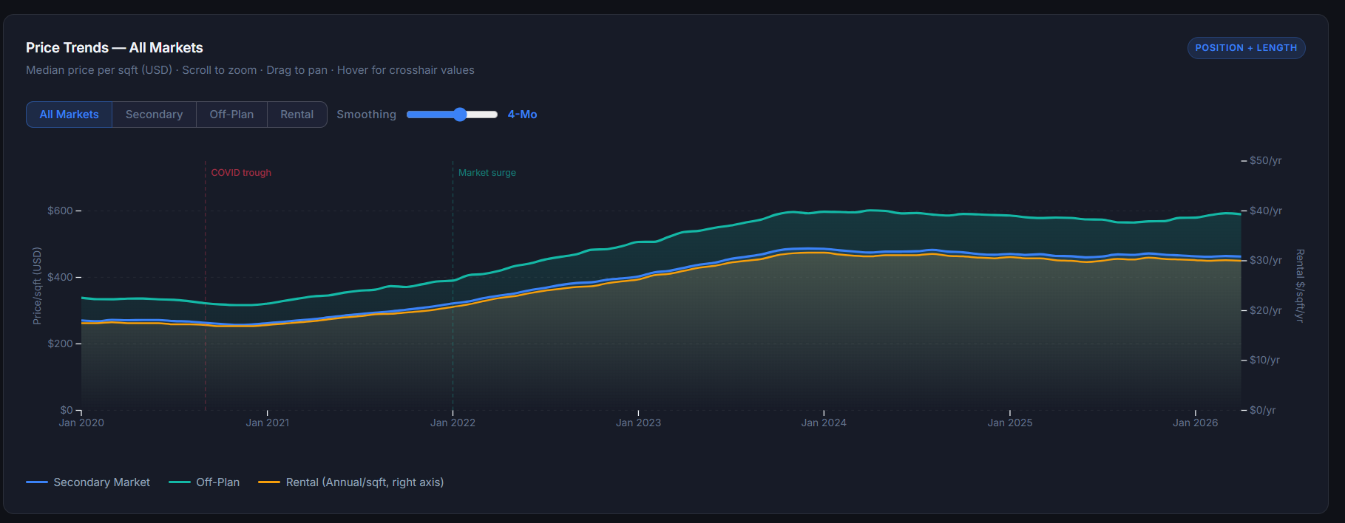
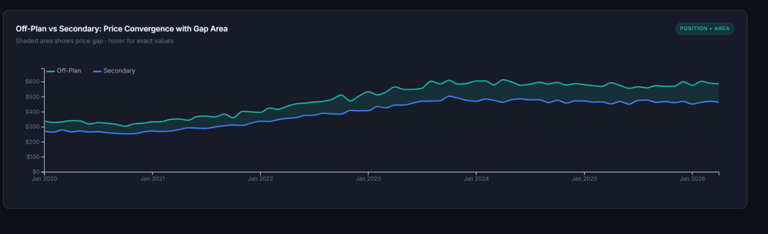Figure 9: Market trend visualization.

Bar Chart
Purpose:
- Compare transaction volumes across locations.
Justification: Bar charts provide accurate comparison of categorical values.
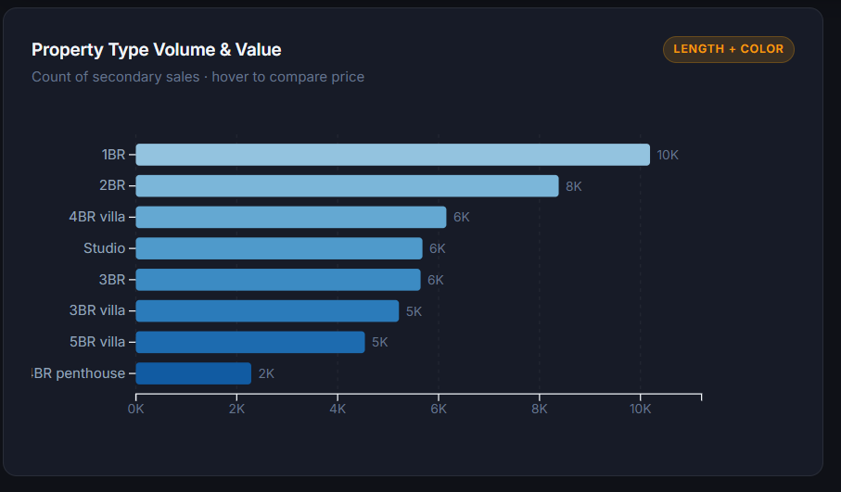
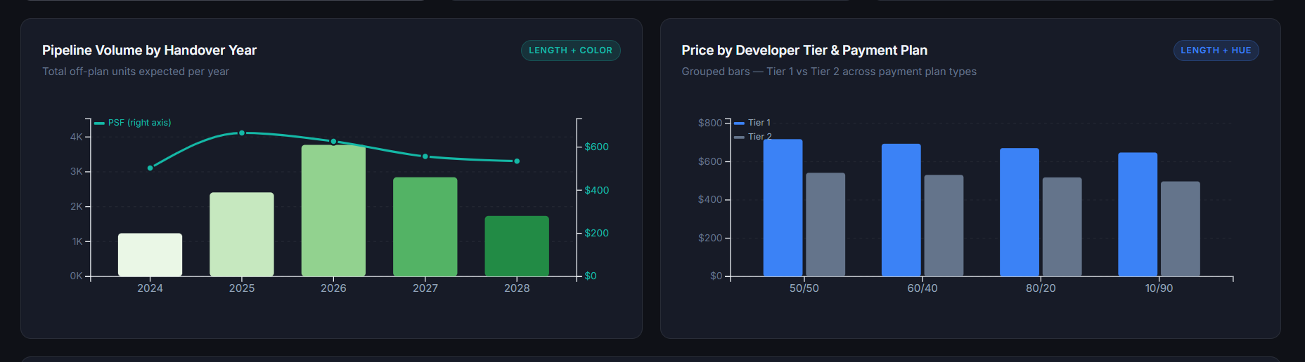
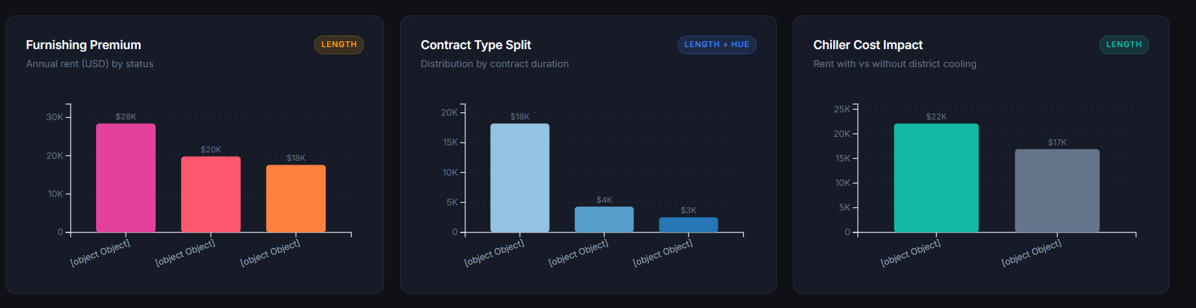Figure 10: Location comparison visualization.

Scatter Plot
Purpose:
- Analyze relationships between property area and price.
Justification: Scatter plots effectively reveal correlations and clusters.
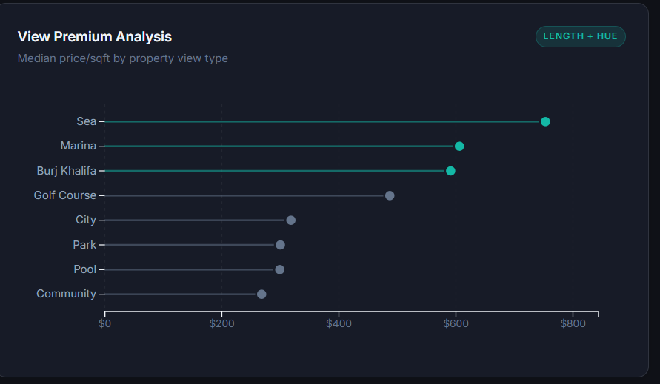
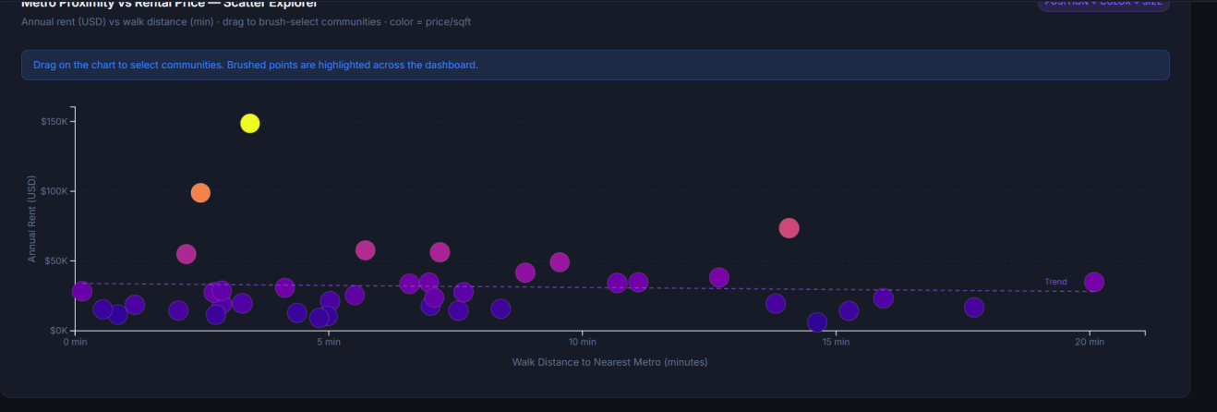Figure 11: Area versus price analysis.

Geographic Visualization
Purpose:
- Display metro station and location-based insights.
Justification: Maps improve spatial understanding of real estate activity.
Figure 12: Geographic visualization.

5. Interaction Techniques Implemented
The dashboard includes several interactive features to improve user experience and facilitate exploratory analysis.

Tooltips
Users can hover over visual elements to obtain detailed information.
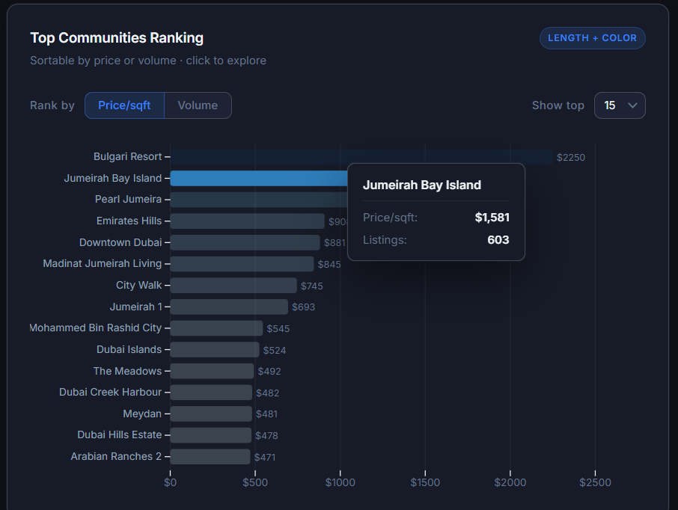Figure 13: Interactive tooltip.

Filtering
Users can filter data based on selected criteria.
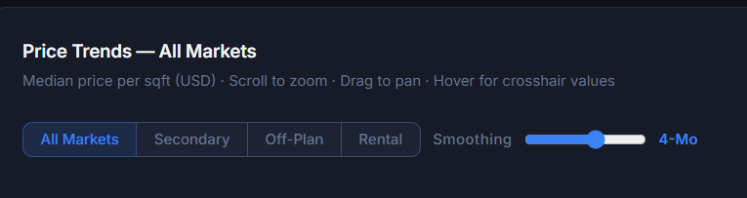
Figure 14: Dashboard filtering functionality.

Zoom and Pan
Users can zoom into detailed sections of visualizations.

Dynamic Updates
Visualizations update automatically based on user selections.

6. Challenges Encountered and Solutions Applied

Challenge 1: Large Dataset Handling
Issue: Rendering large datasets caused slower visualization performance.
Solution: Data aggregation and filtering techniques were applied to reduce rendering overhead.

Challenge 2: Multiple Dataset Integration
Issue: Combining multiple real estate datasets required consistent data structures.
Solution: Data preprocessing pipelines were implemented to standardize formats.

Challenge 3: Responsive Dashboard Design
Issue: Maintaining visualization readability across different screen sizes.
Solution: Responsive layouts and scalable SVG visualizations were implemented.

Challenge 4: User Interaction Design
Issue: Balancing functionality with usability.
Solution: Tooltips, filtering controls, and dynamic updates were carefully designed to provide meaningful interactions without overwhelming users.

Conclusion
PropertyPulse successfully demonstrates the application of D3.js for developing an interactive web-based visualization system. The platform transforms complex Dubai real estate data into meaningful visual insights through effective visualization design, interactive exploration features, and user-centered dashboard development.

